# The Firefox Browser SQLite plugin

## Installing the plugin

If you do not have Firefox already installed on your machine, it can be downloaded from [here](https://www.mozilla.org/en-US/firefox/new/).

Start Firefox and navigate to the [plugin homepage for SQLite](https://addons.mozilla.org/en-US/firefox/addon/sqlite-manager/). Assuming you do this from within the Firefox browser you will be able to install the plugin directly from the page by clicking the Add to Firefox button.

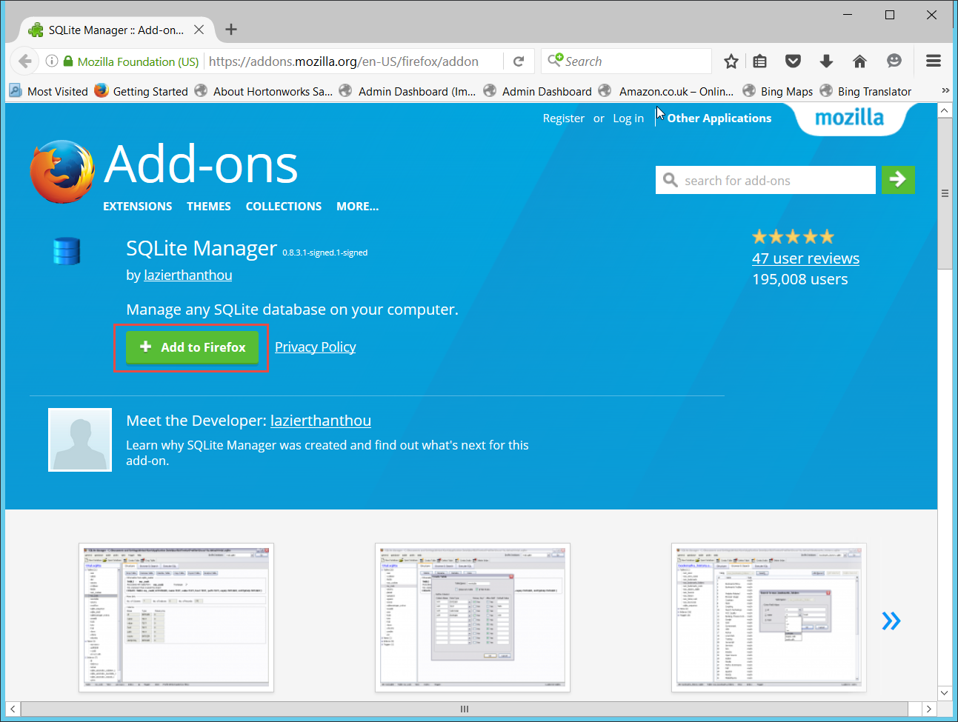

Having done this, the download occurs automatically but you will be asked to confirm that you want to install the plugin. You will then be asked to restart the Firefox browser. After the restart, from the tools menu you will be able to access the SQLite manger plugin.

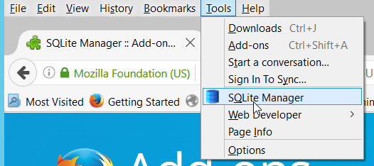

The plugin opens as an ordinary Windows application.

